Create an ArgoCD Application

Now lets tell Argo cd
my-first-app.yaml

apiVersion: argoproj.io/v1alpha1
kind: Application
metadata:
name: guestbook-ui
namespace: argocd
spec:
project: default
source:
repoURL: https://github.com/argoproj/argocd-example-apps.git
path: guestbook
targetRevision: HEAD
destination:
server: https://kubernetes.default.svc
namespace: default
syncPolicy:
automated:
prune: true
selfHeal: true

kubectl apply -f my-first-app.yaml


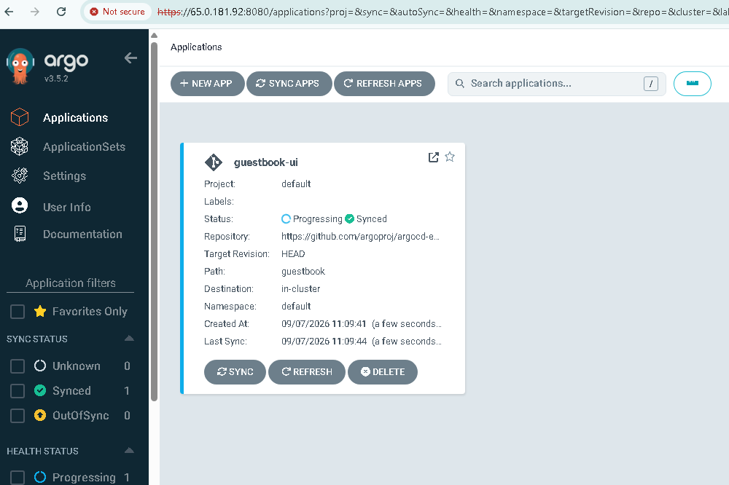
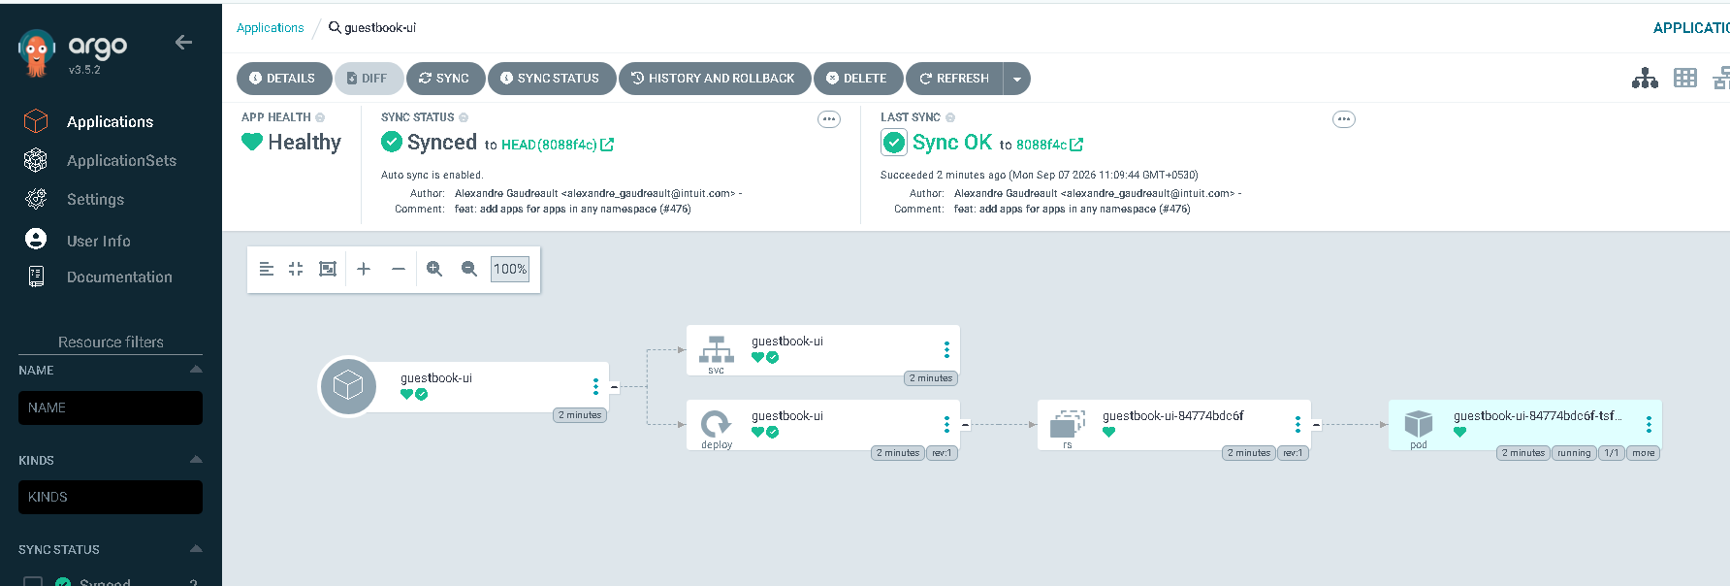

# Step — NOW CREATE THE DRIFT 🚨
kubectl delete deployment guestbook-ui -n default
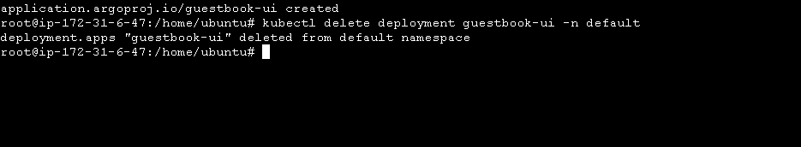
What ArgoCD Does
ArgoCD notices:
Git:
guestbook deployment SHOULD exist
But Kubernetes says:
guestbook deployment DOES NOT exist
Therefore:
Desired State ≠ Live State
ArgoCD detects the difference.
Then, because we configured:
selfHeal: true
ArgoCD automatically recreates the deployment.
## Deployment can be checked from below command
kubectl get deployment guestbook-ui -n default -w

